SYSTEM ARCHITECTURE DOCUMENT Real-Time Weather Data Platform

1. Overview
This system is a real-time data pipeline that ingests weather data from the OpenWeatherMap API, processes and transforms it using Python, and stores both raw and cleaned weather data in a cloud-hosted PostgreSQL database and an S3-compatible data lake.
The platform is designed following modern data engineering principles:
- Modular ingestion
- Scalable transformations
- Lakehouse pattern (Raw → Staging → Analytics)
- Orchestration with Airflow/Prefect
- Data quality validation
- Automated scheduling
- Separation of compute, storage, and orchestration
This architecture supports multiple data sources, multi-city ingestion, historical tracking, analytics, and dashboarding while being deployable on free-tier cloud services.

2. High-Level Architecture Diagram

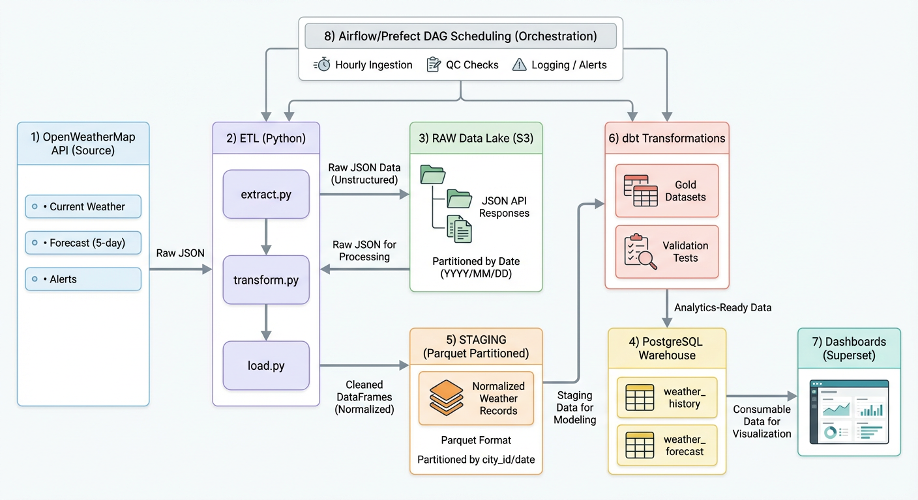

3. Functional Requirements

Extraction
- Fetch weather data for multiple cities
- Pull:
  - Current weather
  - 5-day / 3-hour forecast
  - Weather alerts
- Store raw JSON responses into the data lake

Transformation
- Normalize temperature, wind, and pressure units
- Convert timestamps to:
  - UTC
  - Local timezone for each city
- Validate required fields
- Flatten nested JSON fields (alerts)
- Produce clean, denormalized analytical tables

Loading
- Insert cleaned data into PostgreSQL in:
  - weather_history
  - weather_forecast
  - weather_alerts
- Use bulk inserts or COPY for efficiency
- Maintain historical records (no overwrites)

Orchestration
- Hourly DAG triggered by Airflow or Prefect
- Retry on API failures
- Notify on pipeline failure
- Log run metadata (start/end time, rows processed)

Monitoring
- Detect missing fields from API
- Detect stale data (if API fails for many hours)
- Validate temperature ranges (sanity checks)
- Detect schema drift
- Record pipeline metrics:
  - API latency
  - Rows inserted
  - Error counts

4. Non-Functional Requirements
Requirement | Description
Scalability | Can support dozens of cities; Parquet partitions support large volumes
Data Quality | Must be validated with automated tests
Reliability | Retries + logging ensure robust runs
Cost Efficiency | Built entirely using free-tier components
Extensibility | New data sources or cities can be added without redesign

5. Components Detail

5.1 Extract Layer
Module: extract.py
Features:
- Query API endpoints for:
  - /weather
  - /forecast
  - /alerts (inside OneCall API)
- Parameterized by city list
- Logs latency, status codes, and payload size
- Writes raw responses to:
  - /data_lake/raw/YYYY/MM/DD/city/*.json

5.2 Transform Layer
Module: transform.py
Transforms include:
- Flattening nested objects (main, wind, weather[0])
- Converting:
  - Kelvin → Celsius
  - UTC timestamps
- Creating unique primary keys
- Extracting alert severity + event type
- Handling missing fields
- Creating Parquet partitions:
- /data_lake/staging/city=Victoria/year=2025/month=12/day=04/*.parquet

5.3 Load Layer
Module: load.py
Loads data into PostgreSQL using:
- psycopg2 COPY
- Bulk inserts
- Staged loads to avoid partial inserts
- Error catching + rollback
Tables:
- weather_history
- weather_forecast
- weather_alerts
- cities (city metadata table)

5.4 Orchestration Layer
Using Airflow or Prefect:
DAG Tasks:
- extract_current_weather
- extract_forecast
- extract_alerts
- validate_raw_data
- transform_staging
- load_database
- run_data_quality_checks
- archive_run_logs
Scheduling:
- Run every 60 minutes
- Retry 3 times on failure
- Send notifications (email/Slack webhook)

5.5 Data Lake Layer
Format:
- Raw JSON
- Cleaned Parquet
Benefits:
- Faster analytics
- Cheap storage
- Partitioned for scalable queries
- Decouples processing from database

5.6 Data Quality Layer
Using:
- Custom Python validations
or
- Great Expectations
Checks:
- Missing or null values
- API drift (unexpected fields)
- Value range checks
- Duplicate timestamps
- Row count anomalies
- Time gaps in ingestion

6. Future Extensions
- Near-real-time (every 5 minutes) ingestion
- Adding radar/satellite data
- Geospatial analysis with PostGIS
- Anomaly detection ML model
- Deploying public API for weather history

